DRAFT

Technical Determination of Standards for Mass-Fortification of Foods and Premixes

(The Food Fortification Formulation Calculator)

Omar Dary, Ph.D.

A2Z: The USAID Micronutrient and Child Blindness Project, Washington D.C.

18 March 2007.

Technical Determination of Standards for Mass-Fortification of Foods and Premixes
(The Food Fortification Formulation Calculator)
Omar Dary, Ph.D.
A2Z: The USAID Micronutrient and Child Blindness Project, Washington D.C.

INTRODUCTION

Food fortification is being promoted as the nutritional intervention with the most favorable cost benefit to prevent the physiological and clinical consequences associated with micronutrient deficiencies. Although this statement may be true in many cases, it requires the fulfillment of several conditions such as:

  - Manufacturing of the food under an adequate industrial setting to assure production with cost advantage, food control, and safety;
  - Continuous monitoring of the quality of the product in the factory;
  - Reliable enforcement actions by government authorities to assure compliance of standards and regulations;
  - Use of adequate packaging, labeling, and legitimate nutritional and health claims; and
  - Consumption of the fortified food in amounts and with enough frequency to increase the intake of essential micronutrients for at-risk groups to reach a specific biological threshold of intake but within adequate and safe ranges for those individuals who consume the food in large amounts.

The biological impact on food fortification depends on:

  - The usual amount of the fortified vehicle that is consumed by the target population;
  - The micronutrient content in the food vehicle at the consumer’s table;
  - The bioavailability and bioconversion of the micronutrient; and
  - The magnitude of the nutritional gap to be filled.

The public health significance of food fortification is a function of:

  - Favoring individuals of the population at-risk reach the biological threshold of intake by means of the fortified food; and
  - Keeping the intake below the Tolerable Upper Intake Level (UL) for most individuals consuming the fortified food.
Food fortification is the practice of deliberately increasing the content of essential micronutrients in a food so as to improve the nutritional quality of the food supply and to provide a public health benefit with minimal risk to health (WHO/FAO Guidelines in Food Fortification).

Three types of food fortification have been recognized:

  - Mass fortification refers to the addition of micronutrients to edible products that are consumed regularly by the general public, such as cereals, oils and vegetable fats, milk, and condiments.

  - Targeted fortification refers to the fortification of foods designed for specific population subgroups, such as complementary foods for infants, foods for institutional programs as for example those aimed at pre- and schoolchildren, and foods used under emergency situations.

  - Market-driven fortification refers to a situation in which a food manufacturer takes the initiative to add one or more micronutrients to processed foods in order to increase sales and profits.

There are many factors that make the addition of micronutrients to industrially manufactured foods a need, such as the production of processed foods using ingredients that have low nutritional density, loss of the natural content of nutrients during food processing, particular metabolic needs of certain age groups, monotonous starchy diets, and others. Certainly, food fortification is a human invention that is contributing to improve the health and the well being of people, but it is important to know its nature to make a better use of it.

Countries are often dealing with making the decision of which levels of nutrients to recommend as efficacious but at the same time safe for the population at large. In the past, only the former aspect received attention, especially by public health professionals working with groups at nutritional risk. However, evidence is continuously accumulating that shows that safety also deserves attention. The recent publication by WHO/FAO titled “Guidelines on Food Fortification with Micronutrients” covers both of these issues, and it provides the scientific and technological basis to design, plan, implement, monitor, and evaluate food fortification programs under a public health perspective. The Annex D of that publication describes a procedure for estimating fortification levels for mass-fortification. Although the methodology is relatively simple, the use of different dietary reference values for each target group, the existence of distinct kinds of diet (high, moderate, or low bioavailability for minerals), foods of different nature, and the variety of fortificants (source of micronutrients) might be very challenging and confusing. Thus, the need to make the procedure easier triggered the development of this “Food Fortification Formulation Calculator.” It can be applied to mass-fortification but, with some adaptations, it may also be useful for the other types of fortification. This “Calculator” complements the Annex mentioned above, and it is expected to become a useful tool for program managers.

IMPORTANCE

Despite the scientific knowledge of the complexity of human nutrition and physiology, there are still cases in which food security is conceptualized as simply the supply of foods to provide metabolic energy. The term of “hidden hunger,” launched in the 1990’s to refer to the deficiency of essential nutrients has not yet permeated many sectors, including policy makers in the field of food production and human dietary needs. In the other extreme, there are others, who advocate for raising the intake of only one or a few nutrients, neglecting the promotion of a balanced diet. This approach ignores the fact that health is associated with keeping the metabolic equilibrium (homeostasis) of many substances in human physiology.

Most micronutrients are only obtained through the diet, because humans cannot synthesize them. Those include inorganic cations (substances with positive charge) such as chromium, cobalt, copper, iron, lithium, manganese, molybdenum, nickel, silicon, tin, and zinc. Most of them act as essential players in active centers of enzymes that catalyze many biochemical reactions. Iron also serves as the carrier and storage of oxygen, which is the last receptor of the electrons taken from the foods during the process of energy extraction from carbohydrates, fats, and proteins. Other nutrients in this category, such as sodium, potassium, calcium, and magnesium are used to keep the adequate electric charges at both sides of biomembranes and to maintain the correct osmotic pressure and the acid-base balance of bodily fluids. Calcium is also used in relatively larger amounts to keep the correct structure and resistance (including flexibility) of bones and teeth. Another group of inorganic micronutrients are anions (substances with negative charge), such as arsenic, boron, selenium, sulfur, and vanadium, which also act as catalyst centers of specific enzymatic reactions; chloride to equilibrate cations around membranes, both outside and inside cells; fluoride to give adequate properties to hard tissues of the body; and phosphorus, in relative large amounts, as part of nucleic acids (the substances for genetic storage and expression), membrane phospholipids, proteins, and mineral structures; and iodine as part of basic thyroid hormones that act as gene expression modulators.

Living organisms consumed as foods, both plants and animals, contribute to human nutrition providing organic micronutrients that cannot be synthesized by the human being. Among these are the water soluble vitamins, such as B-1 for carbohydrate processing; B-2 and niacin for helping extracting the energy stored in carbohydrates, fats, and proteins, for destroying undesirable molecules inside the body, and for introducing metabolic energy into the own human biomolecules; B-6 for catalyzing changes associated to amino acids; B-12, biotin, and pantothenic acid for participating as coenzymes in specific reactions of synthesis; folate as the main recycling substrate involving transference of methyl groups (one carbon moieties) during the synthesis of nucleic acids, proteins, phospholipids, and other biomolecules; and vitamin C to keep the adequate oxidative stage of carbohydrates linked to proteins and fats. The other group of organic micronutrients are the lipid soluble vitamins, such as vitamin A and D, which act as gene expression modulators, and the former also as the visual pigment; vitamin E as the main antioxidant for fats; vitamin K as a participant of the reaction of blood clotting and other functions; and β-carotene as an antioxidant and precursor of vitamin A.

The previous list is not complete; it should also include some amino acids and fatty acids that are not synthesized by the human body, but whose study and nutritional interventions are generally not included among the minerals and vitamins, mainly because they form part of macromolecules or supramolecular structures. The list is also lacking of less known substances, mainly from the vegetable kingdom, whose properties in human physiology still need to be revealed.

This list of minerals and vitamins, and their functions, is provided here to illustrate the complexity of human physiology, and to emphasize that all of them must be present in the correct amount for the human body to work well. The description of their functions also shows that those substances are not inert, they are very active molecules, and that is why anomalous amounts of them in the body, either in deficiency or excess can provoke significant alterations.

In the field of selecting appropriate fortification levels, two extremes can occur. In one side are those that look for “universal” recommendations or complete imitation of other country regulations, without considering the composition of the local diet and the pattern of consumption of the food candidate to be fortified. And, in the other side are those that relegate a decision in this regard until results of very laborious and costly dietary surveys, with the purpose of establishing the exact nutritional gap, are known. It is important to realize that in most circumstances the fortification levels for staple foods are not determined by the precision of those measurements, but by technological and economical constrains, as well as the highest consumption pattern of the individual who consume the fortified food. Meticulous dietary surveys are required to estimate the impact of the program, but they are less needed during the designing step. However, a general knowledge of the overall diet quality is still important for a good fortification formulation, but it can be approximated using estimated per capita intake figures, food composition tables and a general appraisal of the diet ingredients.

The “Calculator” is based on the following principles:

- Establishing nutritional goals in terms of percent of the Estimated Average Requirement (EAR) to be provided to individual at the fifth percentile of the consumption pattern of the fortified food;

- Avoiding that individuals at the 95th percentile of consumption have an intake above the Upper Tolerable Intake Level (UL);

- Price increase due to fortification is compatible for keeping the usual practice of production and trade of the fortified food.

STEPS

- Establishing the Nutritional Goals of the Program

Diets of developing countries are usually very simple and depend on a very few ingredients, mainly starchy foods. Thus, it should be a relatively straightforward task to anticipate that micronutrients are more important. The situation is much more complicated in rich societies, where many foods and forms are available, which would require the application of carefully done dietary surveys. In both cases, the nutritional gap of the micronutrients of interest should be approximated.

Dietary surveys carried out in developing countries reflect that the main nutritional deficiencies are those associated to food of animal origin, mainly minerals: iron, zinc, and calcium; and the vitamins B-12 and B-2. In populations that live in regions beyond the 42º Parallel or cover the skin from sun exposure, vitamin D –another vitamin from animal sources- might be lacking. If the diet is poor in whole cereals and legumes (beans, peas, chick peas, and the like), folate, niacin, and vitamins B-1 and B-6 might also be insufficient. Vitamin C deficiency, although uncommon, may appear if the consumption of fruits and fresh vegetables is low. Deficiency of iodine is widespread regardless of the socio-economical level, except for populations that consume diets rich in seafood.

Many developing countries lack sufficient information to estimate the nutritional adequacy of micronutrients in their population. Thus, as a starting point for planning their nutritional interventions programs, some values are suggested in Table 1. Later, once a specific intervention is established, monitoring and evaluation efforts could be used to obtain better dietary information that would be applicable to refine the formulation of the fortification program. However, lack of detailed dietary information should not delay taking the decision of introducing a fortification program, because poor starchy diets are almost certain to be micronutrient poor.

Table 1
Suggested nutritional goals for increasing micronutrient intakes in developing countries.

100 % EAR | 80% EAR | 60% EAR | 40% EAR
Iodine | Vitamin A | Vitamin B-2 | Vitamin B-1
- | Folate | Calcium | Niacin
- | Vitamin B-12 | - | Vitamin B-6
- | Iron | - | Vit. C
- | Zinc | - | Vit. D
Table 1 presents the goals in terms of EAR and not the Recommended Nutrient Intake (RNI), because this is the recommended dietary parameters to diagnose status and to design nutritional interventions at the population level. With the exception of iron, EAR are usually 80 percent the values of RNI. The needs of iron are highly variable in a population, mainly among reproductive age women, and hence the difference between EAR and RNI is large. Although the “Calculator” focuses on the proportion of EAR that is supplied by the consumption of the fortified food, it also presents the proportion of the additional intake in terms of RNI. Figure 1 illustrates the position of the three main Dietary Parameters EAR, RNI, and UL, and their association with risk of inadequacy and risk of excess.

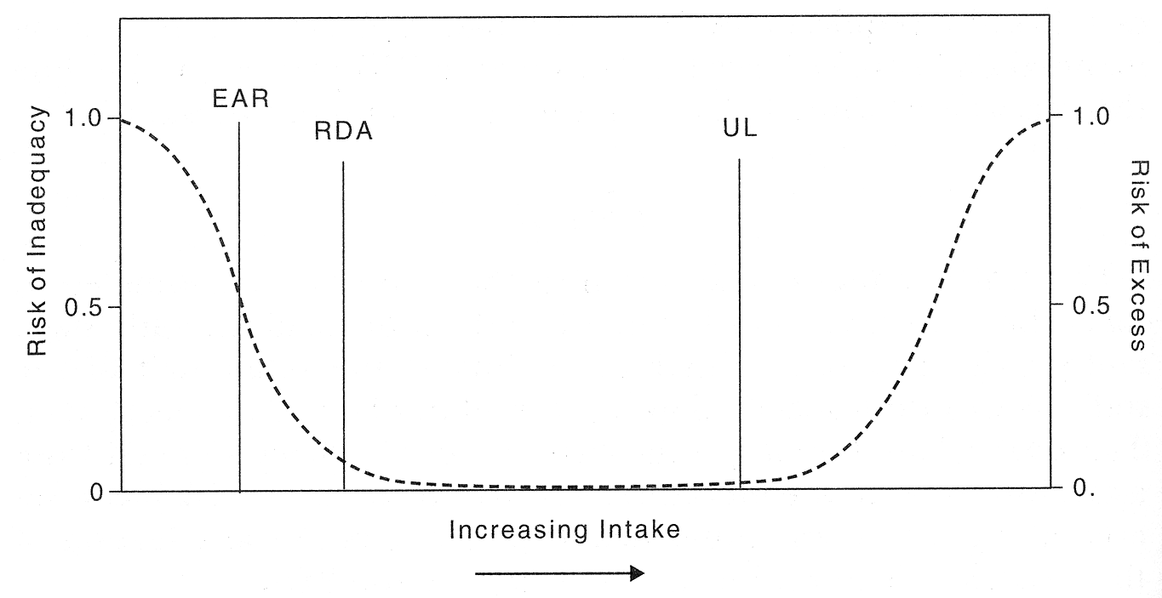

Figure 1. Dietary Reference Intakes (EAR, RDA or RNI, UL). Institute of Medicine, Academies of Science of the USA. Dietary Reference Intakes. Applications in Dietary Assessment, 2001.

- Approximating the Intake of Micronutrient with Low UL Values

Oddly, most of the micronutrients whose intake should be increased among at risk-groups are also classified in the group of micronutrients whose excessive intakes might cause adverse effects. Those are the vitamins A (as retinol) and D, iodine, and calcium. Fluoride is another mineral in this group. If there are reasonable justifications that some individuals in the population who will consume the fortified foods are already receiving large amounts of those nutrients through the diet, an effort should be done to measure the usual intake of those micronutrients by those individuals. These values are used by the “Calculator” to estimated an “adjusted” UL; i.e. the UL minus the usual largest dietary intake of the micronutrients of concern.

Once a micronutrient intervention has been introduced, either through fortified foods or through preventive supplementation, the highest additional intake associated to those interventions should be used to calculate accordingly the “adjusted” UL for new interventions. In this case, in addition to vitamins A and D, iodine, calcium, and fluoride, it is important to include niacin if supplied by means of nicotinic acid, folic acid, iron, NaFeEDTA (independent of the supply of iron), and zinc.

- Deciding the Maximum Increase in the Price due to Fortification

Fortification should have a low impact in the price of the food vehicle in order to facilitate compliance and creation of a level playing field among producers. If the price increase is too high, the possibility of incompliance or risks of corruption may hinder the programmatic feasibility of the program. Values around 0.5 percent to 2 percent have been found acceptable in this regard. In the case of targeted-fortification and market-driven fortification, increase in the price is not as sensitive as with mass-fortification, because they are special type of products, whose prices depend on other factors, such as industrial processing, packaging, and commercial advertising. Staples, because of their large consumption and their use as ingredients for other industries, are very vulnerable to price differences.

- Estimating Usual Consumption Figures of the Fortification Vehicle

Ideally, the consumption profile of the fortification vehicle should be known for each one of the age- and sex-groups of the population. However, this is very difficult information to obtain, especially for a program that has not started yet. A practical approach is to use the calculated per capita estimation. Nevertheless, it is important that this value is estimated only for the proportion of the population that consumes the food. For example, if one calculates that the per capita intake of certain food in a country is 80 g/day, but only 60 percentof the population has access to it, then the per capita consumption of that food by the true consumers is: 80/0.6 = 133 g/day.

In many circumstances the per capita intake coincides better with the consumption of adult women rather than with the consumption of adult males. To approximate the consumption pattern of the other member of the family, an adjustment for proportional energy requirement could be done. Table 2 illustrates the proportional energy intake for different groups, using women as the reference.

Table 2
Adjustment factors to approximate the per capita intake of staples for each age group based on female “adult equivalent”

Parameter | Children (age in years) |  |  | Females (age in years) |  |  |  | Males (age in years)
Parameter | ( 1- 3) | (4 – 6) | (7-9) | (10-18) | (19-50) | (51-65) | (+65) | (10-18) | (19-50) | (51-65) | (+65)
Daily energy requirement  (kcal/day) | 1,350 | 1,600 | 2,000 | 2,000 | 2,100 | 2,100 | 1,850 | 2,500 | 3,100 | 3,100 | 2,300
Adjustment Factor | 0.64 | 0.76 | 0.95 | 0.95 | 1.00 | 1.00 | 0.88 | 1.19 | 1.48 | 1.48 | 1.10

For example, if one is interested in approximating the per capita consumption of the food for children 4-6 years old, then the calculation would be: 133 g/day x 0.76 = 101 g/day. This approximation may be far from reality when foods are preferentially given to certain age groups, such as sugar and milk to infants and small children.

In addition to the average intake, the distribution profile is also needed. This information is even more difficult to obtain. The “Calculator” approximates the consumptions figures at percentiles 5, 50, and 95, dividing the per capita values by 2.0 and 1.3 (because the usually skewed distribution of the consumption patterns toward the high values), and multiplying by 2.0, respectively. Nevertheless, the user can input more accurate values if they are known.

- Assessing the Nutritional Impact and Selecting the Fortification Levels

The “Calculator” processes the information about the food consumption profile to select one out of three fortification formulas (high, medium, and low consumption patterns). The “Calculator” also uses usual losses of the micronutrients during production, storage, distribution, and cooking, to have a raw estimation of the fortification level at the consumer’s table. As an output, the “Calculator” presents the additional intake of micronutrients in terms of %EAR and %RNI, as well as absolute amounts in mg/day, at P-5, P50 and P-95 percentiles of consumption. It is important to keep in mind that for designing complementary interventions, two values are important: (a) the absolute additional intake of micronutrients at P-95 percentile, which will be used for estimating the new “adjusted” UL; and (b) Additional %EAR at the P-5 percentile, which may be subtracted from the nutritional goal.

Other information provided by the “Calculator” is the cost of the forficant per metric ton of fortified food. In the case of mass-fortification carried out under industrial settings, between 85 to 95 percent of the cost of the fortification process is due to the cost of the fortificant. Therefore, the information about the cost of the fortificants is a very good approximation of the overall cost of the program.

The user of the “Calculator” may try other fortification levels as he/she wishes. The “Calculator” will reprocess the information until the user is satisfied with the outputs. The user should analyze the selected fortification formula for other target groups to confirm that it will not provide excessive intakes to them (i.e. additional intake should be below the “adjusted” UL value); this is especially valid for children 4-6 years old and adult males. If excessive intakes were found, then the levels should be reduced as needed.

- Calculating the Fortification Parameters

Once the user has selected the fortification levels that better fulfill the nutritional goals and the economic possibilities, the “Calculator” will estimate the average content of each micronutrient in the food at the moment of production. The average content results from the addition of the selected fortification level to the intrinsic content of the corresponding micronutrient in the unfortified food. The “Calculator” will also estimate the minimum (mFL) and the maximum (MFL) fortification levels during production, by means of subtracting and adding, respectively, two coefficients of variation of the fortification process, when it is carried out under realistic but still acceptable conditions of performance.

The “Calculator” will also suggest the Regulatory Parameters, i.e. the legal minimum (LmL) and the Maximum Tolerable Level (MTM) of the fortified food for standards and enforcement purposes. The legal minimum originates from subtracting the expected decay of the micronutrient during storage, distribution and marketing of the food during the expected marketing life. The MTL coincides with the maximum production content, and it is mainly applicable to those micronutrients with low UL values. Figure 2 illustrates graphically the meaning of the fortification parameters mentioned here.

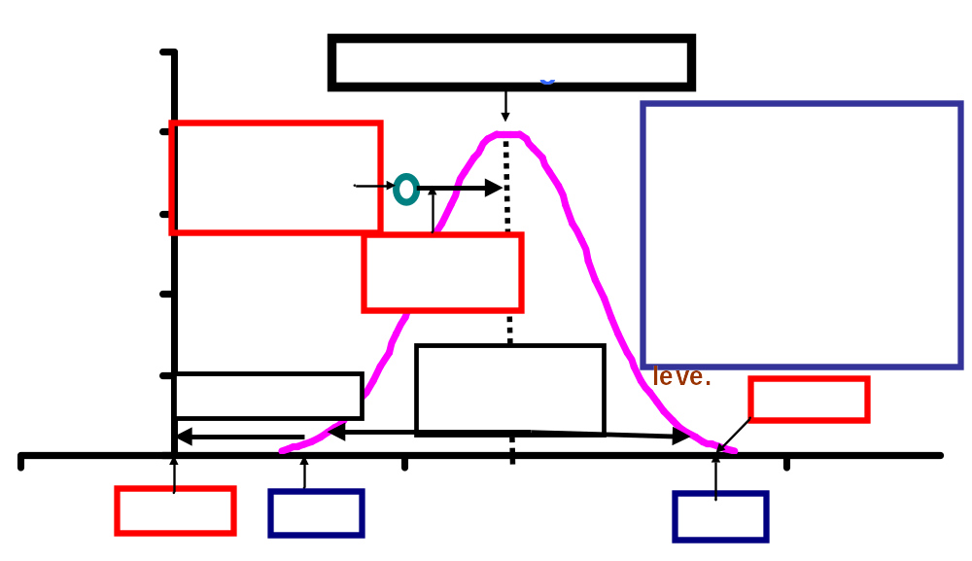

Figure 2. Food Fortification Parameters. Modified from the WHO/FAO Guidelines on Food Fortification with Micronutrients.

- Formulating the Premix

The final output of the “Calculator” is the estimation of the premix formulation. Each selected micronutrient is supplied by a fortificant, in which only a proportion of its composition is the micronutrient. Therefore, the amount of fortificant to add will be larger than the micronutrient content that is selected. Furthermore, in many occasions other substances in addition to the fortificants are incorporated to the premix to improve fluidity and stability. Thus, there is a minimum weight and volume that is compatible with the selected fortification formula. Consequently, there is a maximum dilution factor; i.e. the final amount of fortified food produced per a specific amount of the premix. It is not possible to reduce that amount of premix without decreasing the micronutrient content in the fortified food. Likewise, the dilution factor estimated under this condition cannot be increased (i.e. use less premix per volume of food) if the selected fortification levels want to be attained. However, the user may decide to use larger amounts of premix. In this case, filling material is incorporated to the premix in order to increase its weight and volume. In other words, a larger amount of premix is used, and hence the dilution factor is reduced. Dilution factors around 1,000 to 3,000 are customary in mass-fortification.
DESCRIPTION OF THE “CALCULATOR”

The “Calculator” is a spreadsheet written in the program Excel. It is constituted by 12 linked worksheets with data entry, reference values and calculations, and an introduction cover. The worksheets are identified with different a color depending on the use. Thus:

- Purple: Instructions.
- Yellow: Input data. Note: Cells in yellow in other worksheet also indicate data to be entered by the user.
- Clear Yellow: Data that is suggested by the “Calculator” but that can be overwritten by the user. Note: Cells in clear yellow in other worksheet also indicate data to be entered by the user.
- Blue: Output data.
- Gray: Reference values.

The sequence of worksheets is as follows:

Introduction (Purple)
  - Inputs (Yellow)
  - A. Selecting Levels (Yellow)
  - B. Fortification Parameters (Blue)
  - C. Premix Formulation (Blue)
  - Technical Information (Clear Yellow)
  - EAR Values (Gray)
  - RNI Values (Clear Yellow)
  - UL Values (Clear Yellow)
  - Conversion Factors (from RNI to EAR) (Gray)
  - Price of Fortificants (Clear Yellow)
  - Intrinsic Micronutrient Contents (Clear Yellow)
  - Fortification Formulas (Gray)

Thus far, “Calculators” have been produced for the following foods:

Salt | Sugar | Oil | Refined wheat flour | Whole wheat flour
Maize flour | Whole maize flour | Masa flour | Dry Milk | Fluid Milk

INSTRUCTIONS FOR THE USE AND INTERPRETATION OF THE CALCULATOR

- Inputs

This worksheet receives the basic input data from the user, as follows:

- Cell B3: Selection of the target group from 11 possible options.
- Cell B5: Price of the food before fortification.
- Cell B7: Maximum acceptable increase in the price of the food due to the fortificants.
- Cell B9: Per capita consumption of the food by the selected target group in g/day (or mL/day for liquids).
- Cell B11: The “Calculator” estimates the consumption at P-50, dividing the per capita consumption by 1.3. The user may introduce another value. Caution: Once another value is recorded, the program no longer responds to Cell B9.
- Cell B13: The “Calculator” estimates the consumption at P-5, dividing the per capita consumption by 2.0. The user may introduce another value. Caution: Once another value is recorded, the program no longer responds to Cell B9.
- Cell B15: The “Calculator” estimates the consumption at P-95, multiplying the per capita consumption by 2.0. The user may introduce another value. Caution: Once another value is recorded, the program no longer responds to Cell B9.
- Cell B17: The number of micronutrients that are expected to add into the food. This value is used by the “Calculator” to estimate the percent of price increase for each micronutrient, dividing the accepted percent of increase by the number of micronutrients.
- Cell B19: For the “calculators” of salt, sugar, refined wheat flour, maize flour (without germ), and dry milk, the information if the diet is rich in mineral (mainly for iron) absorption inhibitors should be specified. If the response is YES, the “Calculator” will select the EAR and RNI values corresponding to this type of diet. Otherwise, the values will be those for a diet with moderate bioavailability for minerals.
- Cells B24 to B46: Maximum estimated intake, through the diet, of the micronutrients whose excessive intake is undesirable by the population that is going to consume the fortified food in mg/day.
- Cells C24 to C46: Additional intake of micronutrients at P-95, by means of other fortified foods or supplementation, whose excessive intake is undesirable in mg/day.
- Cells D24 to D46: The “Calculator” estimates the intake of micronutrients with low UL before the introduction of the new fortified food.
- Cells E24 to E46: The intake goals of the program expressed in terms of %EAR.
- A. Selecting Levels

This worksheet is the most important of the spreadsheet. It is here where the decisions regarding micronutrient levels will be made by the user.

- Cells C8, G8 and K8: The “Calculator” reproduces the P-5, P-50 and P-95 consumption values as specified in Inputs.
- Cells EF10 to 12: The “Calculator” shows the user the reference consumption ranges that are used to classify the consumption pattern of the target population as: high, medium or low. The fortification levels that are recommended in column D of the Table are those specified for the type of diet mentioned in Cell H11.
- Cell L11: For those spreadsheets where the alternative to indicate if the diet is rich in iron absorption inhibitors will show here if the mineral bioavailability is low or moderate. Note: The “Calculator” does not use Dietary Reference Values for diets that are highly bioavailable for minerals.
- Some rows of the table can appear with a dotted pattern to indicate that there is more than one alternative for the same nutrient, or that the micronutrient has been included to allow the user further analysis despite that addition is not suggested.
- Column C of the Table: The calculator shows the Feasible Fortification Level; i.e. the maximum content of micronutrients that is compatible with the three limiting factors: technological, safety, and cost, as calculated in Technical Information (5).
- Column D of the Table: The “Calculator” shows here specific recommended fortification levels accordingly with the consumption range (high, medium or low).
- Column E of the Table: The “Calculator” copies here the same information than in column D, but the user can modify it. Caution: Once another value is used, the program no longer copies the recommended fortification levels in this column.
- Column F of the Table: The “Calculator” estimates here the fortificant cost in US$/MT (1 MT = 1,000 kg) at the selected fortification level in column E. At the bottom of the column, the total cost and percent of price increase are shown.
- Column G of the Table: The “Calculator” reproduces here the intake goals as specified in the Inputs worksheet.
- Columns H, I and J of the Table: The “Calculator” estimates here the additional intake of each added micronutrient in terms of %EAR at P-5, P-50 and P-95 percentiles of consumption. The calculations take in consideration the losses of some micronutrients during storage, distribution and marketing, as well as cooking, as assumed in the Technical Information worksheet (5). Note: The intakes of folic acid and vitamin B-12 are multiplied by 1.7 and 2.0, respectively, taken in consideration the larger bioavailability of the synthetic forms than the natural sources.
- Columns K, L and M of the Table: The “Calculator” estimates here the absolute additional intake of each added micronutrient, expressed in mg/day, at P-5, P50 and P-95 percentiles of consumption.
- Column N of the Table: The “Calculator” shows here the adjusted UL value; i.e. the UL minus the intakes recorded in the Input worksheet.
- Columns O, P and Q of the Table: The “Calculator” estimates here the additional intakes of each micronutrients in terms of %RNI, based on the same assumption as for the estimations of the %EAR.

- B. Fortification Parameters

This worksheet shows the production and regulatory parameters that will be useful to establish the quality control criteria, as well as the micronutrient contents that should appear in standards and regulations. The calculations are done assuming the conditions specified in Technical Information worksheet (5).
- Column B: The name of the nutrients.
- Column C: The name of the fortificant compounds (source of micronutrients).
- Column D: The selected fortification levels (FL) as done in the Selecting Levels worksheet (2).
- Column E: The minimum fortification level (mFL) during production.
- Column F: The average fortification level during production.
- Column G: The maximum fortification level (MFL) during production.
- Column H: The legal minimum level (LmL), after considering losses of micronutrients during distribution and marketing.
- Column I: The Maximum Tolerable Level. It coincides with the MFL, and it may be avoided for those nutrients whose UL are very high.

- Premix Formulation

This worksheet shows the possible formulation of the premix. The user has the possibility to increase the amount of premix per metric ton of fortified food (which is equivalent to reduce the dilution factor).
- Cell D7: The calculated minimum amount of premix (grams per metric ton of food) to attain the micronutrient contents as they have been selected by the user.
- Cell D8: The user can increase the amount of the premix with the purpose of reducing the dilution factor and improve homogeneity. The additional weight that is needed to incorporate will be added as filling material, and it is calculated at the bottom of column F.
- Cells I7 and I8: The dilution factors accordingly to the minimum amount and the selected amount of premix, respectively.
- Column B: The name of the nutrients.
- Column C: The name of the fortificant compounds (source of micronutrients).
- Column D: The selected fortification levels (FL) as done in the Selecting Levels worksheet (2).
- Column E: The amount of the fortificants that are needed in order to attain the selected level of each micronutrient. It takes in consideration the proportion of micronutrient in the fortificant.
- Columns F and G: The amounts of fortificant and the corresponding micronutrient in the premix formulated to be added in the amount specified by the user in Cell D8.
- Column H and I: The cost of the premix, expressed in US$/kg and % of the total cost, respectively.

- Technical Information

This worksheet contains several parameters that determine the feasible fortification level (FFL), such as the technological, safety and cost limits. It also includes data about the variation of the micronutrient content during production, micronutrient losses during marketing and during cooking. The “Calculator” suggests some values for all these parameters, but they can be changed by the user with his/her own data.

- Column B: The name of the nutrients.
- Column C: The name of the fortificant compounds (source of micronutrients).
- Column D: Losses of the micronutrients during marketing as %.
- Column E: Losses of the micronutrients during cooking as %.
- Column F: Expected average loss of micronutrients before consumption. These values are used to estimate the content of micronutrient that reaches the consumer’s table, with the purpose of calculating the additional intake based on the consumption patterns.
- Column G: Coefficient of variation of the fortification process. These values are used to estimate the minimum and maximum contents of micronutrients during production.
- Column H: Technological Limit. The maximum amount of each micronutrient that does not affect the sensorial properties of the fortified food. These values should be determined experimentally, both for the fortified food as well as for the products in which it is used as an ingredient.
- Column I: Safety Limit: This is the maximum content of micronutrients that can be added without providing the UL to the P-95 consumption pattern.
- Column J: Cost Limit: This is the maximum content of micronutrients that can be added within the price increase specified in the Inputs worksheet (2). This is the most flexible of the limits, and it is a decision of the user to go over it if cost is considered compatible for the program.
- Column K: The Feasible Fortification Level: The lowest value among the technological, safety and cost limits.

- EAR Values

This worksheet presents the estimated EAR values for 11 age- and gender- groups, calculated from the WHO/FAO RNI values and the conversion factors specified in the Conversion Factors worksheet (9). In the case of iron and zinc, values for moderate and low bioavailability diets are specified. Approximate figures for different types of iron compounds are also included.

- RNI Values

This worksheet presents the RNI values for 11 age- and gender- groups, as recommended by WHO/FAO. In the case of iron and zinc, values for moderate and low bioavailability diets are specified. Approximate figures for different types of iron compounds are also included. The user can input here other values.

- UL Values

This worksheet presents the currently accepted UL values by WHO/FAO. Few data come from the Institute of Medicine, Academies of Science of the USA. The user can input here other values.

- Conversion Factors

This worksheet presents the conversion factors as recommend by the WHO/FAO Guidelines on Food Fortification with Micronutrients in order to transform RNI values into EAR values.

- Price of Fortificants

This worksheet presents currently prices from vitamin and mineral providers, as well as the proportion of micronutrient in each fortificant. The user can input here other values.

- Intrinsic Micronutrient Contents

This worksheet shows the micronutrient content of the 8 foods for which “Calculators:” have been made. The user can input here other values.

- Fortification Formulas

This worksheet contains suggested micronutrient levels that can be used to select the final fortification level. The user cannot modify this worksheet, but he/she can decide for whatever other level in the Column E of the Selecting Levels worksheet (2).

DISCLAIMER/ ACKNOWLEDGEMENTS/ NOTES

This program is the result of a joint initiative of the Micronutrient Unit of the Department of Nutrition for Health and Development of WHO and A2Z: the USAID Micronutrient and Child Blindness Project. This calculator will facilitate the use of the recommendations of the WHO/FAO Guidelines on Food Fortification with Micronutrients (Lindsay A, de Benoist B, Dary O, Hurrell R (Eds), 2006). The program was conceptualized and designed by Omar Dary, Food Fortification Specialist of A2Z. Michael Hainsworth contributed his expertise and skills to make this Excel spreadsheet program.

The name of the spreadsheet, as well as part of the overall framework was inspired by the spreadsheet titled the “ CSHGP Lives Saved calculator” and used by the Child Health Epidemiology Reference Group or CHERG (also known as “the Bellagio Group”).

This computational program may still have errors and it can be improved. Thus, we would appreciate the users to send comments, corrections and suggestions to Carolina Covarrubias, A2Z, at ccovarrubias@aed.org. Academy for Educational Development (AED), 1825 Connecticut Avenue, NW, Washington, DC 20009-5271, USA.

Version: March, 2007.

Exceptions are some amounts of niacin that is synthesized from the amino acid trypthophan; and vitamin D from dehydrocholesterol and skin exposure to ultraviolet light.
EAR is the average (median) daily nutrient intake level estimated to meet the needs of half the healthy individuals in a particular age and gender group.
UL it the highest average daily nutrient intake level unlikely to pose risk of adverse health effects to almost all (97.5%) apparently healthy individuals in an age- and sex-specific population group.
RNI is the daily intake that meets the nutrient requirements of almost all apparently healthy individuals in an age- and sex-specific population group. It is set at the EAR plus two Standard Deviations.
Based on dietary energy intake of Central American populations. Data from the Institute of Nutrition of Central America and Panama (INCAP)
Fortificant is the source of the micronutrients. For example ferrous fumarate as a source of iron. Ferrous fumarate is 32 percent iron.

